Rockbuster Stealth LLC

Data Dictionary

Matt Fielder

05-April-2023

Table of Contents

Entity Relationship Diagram (ERD) 4

Tables 5

Table: Rental 6

Table: Payment 7

Table: Staff 8

Table: Customer 9

Table: Address 10

Table: City 11

Table: country 12

Table: Inventory 13

Table: Film_category 14

Table: Film_actor 15

Table: Actor 16

Table: Category 17

Table: Film 18

Table: Language 19

Table: Store 20

Views 21

View: Actor_info 22

View: Customer_list 22

View: Film_list 22

View: Nicer_but_slower_film_list 23

View: Sales_by_film_category 23

View: Sales_by_store 23

View: Staff_list 24

View: Top_10_countries_w_customers 24

# Entity Relationship Diagram (ERD)

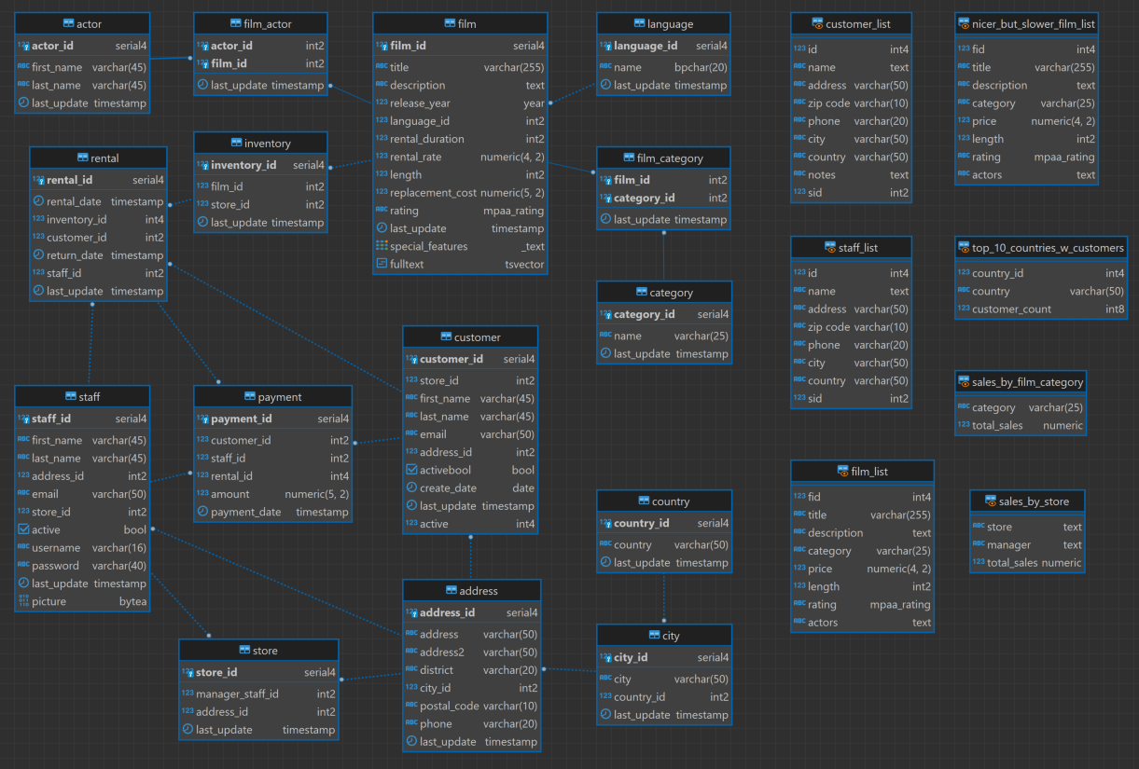

# Tables

## Table: Rental

Rental information for a single movie rental

|  |  |  |  |  |  |
| --- | --- | --- | --- | --- | --- |
| Key | Column Name | Data Type | Not Null | Default | Description |
| PK | rental_id | serial4 | X | nextval('rental_rental_id_seq'::regclass) | ID of the rental |
|  | rental_date | timestamp | X |  | Date of rental |
| FK | inventory_id | int4 | X |  | ID of item rented |
| FK | customer_id | int2 | X |  | ID of customer |
|  | return_date | timestamp |  |  | Date rental returned |
| FK | staff_id | int2 | X |  | ID of staff renting |
|  | last_update | timestamp | X | now() | Timestamp of last update of record |

Link To:

|  |  |
| --- | --- |
| Table | Join on |
| Payment | rental.rental_id = payment.rental_id |

Link From:

|  |  |
| --- | --- |
| Table | Join on |
| Inventory | inventory.inventory_id = rental.inventory_id |
| Customer | customer.customer_id = rental.customer_id |
| Staff | staff.staff_id = rental.staff_id |

## Table: Payment

Rental payment information

|  |  |  |  |  |  |
| --- | --- | --- | --- | --- | --- |
| Key | Columns | Data Type | Not Null | Default | Description |
| PK | payment_id | serial4 | X | nextval('payment_payment_id_seq'::regclass) | ID of payment |
| FK | customer_id | int2 | X |  | ID of customer |
| FK | staff_id | int2 | X |  | ID of staff renting |
| FK | rental_id | int4 | X |  | ID of the rental |
|  | amount | numeric(5, 2) | X |  | Cost of rental |
|  | payment_date | timestamp | X |  | Date of rental payment |

Link To:

|  |  |
| --- | --- |
| Table | Join on |
| None |  |

Link From:

|  |  |
| --- | --- |
| Table | Join on |
| Rental | rental.rental_id = payment.rental_id |
| Customer | customer.customer_id = payment.customer_id |
| Staff | staff.staff_id = payment.staff_id |

## Table: Staff

Staff details

|  |  |  |  |  |  |
| --- | --- | --- | --- | --- | --- |
| Key | Columns | Data Type | Not Null | Default | Description |
| PK | staff_id | serial4 | X | nextval('staff_staff_id_seq'::regclass) | ID of staff renting |
|  | first_name | varchar(45) | X |  | First name of staff member |
|  | last_name | varchar(45) | X |  | Last name of staff member |
| FK | address_id | int2 | X |  | ID of address |
|  | email | varchar(50) |  |  | email of staff member |
|  | store_id | int2 | X |  | ID of store renting |
|  | active | bool | X | true | Flag if staff is active staff |
|  | username | varchar(16) | X |  | Username of staff member |
|  | password | varchar(40) |  |  | Password of staff member |
|  | last_update | timestamp | X | now() | Timestamp of last update of record |
|  | picture | bytea |  |  | Picture of staff member |

Link To:

|  |  |
| --- | --- |
| Table | Join on |
| Rental | staff.staff_id = rental.staff_id |
| Payment | staff.staff_id = payment.staff_id |
| Store | staff.staff_id = store.manager_staff_id |

Link From:

|  |  |
| --- | --- |
| Table | Join on |
| Address | address.address_id = staff.address_id |

## Table: Customer

Customer details

|  |  |  |  |  |  |
| --- | --- | --- | --- | --- | --- |
| Key | Columns | Data Type | Not Null | Default | Description |
| PK | customer_id | serial4 | X | nextval('customer_customer_id_seq'::regclass) | ID of customer |
|  | store_id | int2 | X |  | ID of store |
|  | first_name | varchar(45) | X |  | First name of customer |
|  | last_name | varchar(45) | X |  | Last name of customer |
|  | email | varchar(50) |  |  | Email of customer |
| FK | address_id | int2 | X |  | ID of address |
|  | activebool | bool | X | true | Flag if customer is active or not |
|  | create_date | date | X | 'now'::text::date | Date customer was created |
|  | last_update | timestamp |  | now() | Timestamp of last update of record |
|  | active | int4 |  |  | Active status int |

Link To:

|  |  |
| --- | --- |
| Table | Join on |
| Rental | customer.customer_id = rental.customer_id |
| Payment | customer.customer_id = payment.customer_id |

Link From:

|  |  |
| --- | --- |
| Table | Join on |
| Address | address.address_id = customer.address_id |

## Table: Address

All addresses

|  |  |  |  |  |  |
| --- | --- | --- | --- | --- | --- |
| Key | Columns | Data Type | Not Null | Default | Description |
| PK | address_id | serial4 | X | nextval('address_address_id_seq'::regclass) | ID of address |
|  | address | varchar(50) | X |  | Address |
|  | address2 | varchar(50) |  |  | Address 2 |
|  | district | varchar(20) | X |  | District |
| FK | city_id | int2 | X |  | ID of city |
|  | postal_code | varchar(10) |  |  | Postal code |
|  | phone | varchar(20) | X |  | Phone number |
|  | last_update | timestamp | X | now() | Timestamp of last update of record |

Link To:

|  |  |
| --- | --- |
| Table | Join on |
| Staff | address.address_id = staff.address_id |
| Customer | address.address_id = customer.address_id |
| Store | address.address_id = store.address_id |

Link From:

|  |  |
| --- | --- |
| Table | Join on |
| City | city.city_id = address.city_id |

## Table: City

All cities

|  |  |  |  |  |  |
| --- | --- | --- | --- | --- | --- |
| Key | Columns | Data Type | Not Null | Default | Description |
| PK | city_id | serial4 | X | nextval('city_city_id_seq'::regclass) | ID of city |
|  | city | varchar(50) | X |  | City name |
| FK | country_id | int2 | X |  | ID of country |
|  | last_update | timestamp | X | now() | Timestamp of last update of record |

Link To:

|  |  |
| --- | --- |
| Table | Join on |
| Address | city.city_id = address.city_id |

Link From:

|  |  |
| --- | --- |
| Table | Join on |
| Country | country.country_id = city.country_id |

## Table: country

All countries

|  |  |  |  |  |  |
| --- | --- | --- | --- | --- | --- |
| Key | Columns | Data Type | Not Null | Default | Description |
| PK | country_id | serial4 | X | nextval('country_country_id_seq'::regclass) | ID of country |
|  | country | varchar(50) | X |  | Country name |
|  | last_update | timestamp | X | now() | Timestamp of last update of record |

Link To:

|  |  |
| --- | --- |
| Table | Join on |
| City | country.country_id = city.country_id |

Link From:

|  |  |
| --- | --- |
| Table | Join on |
| None |  |

## Table: Inventory

Movie inventory by store

|  |  |  |  |  |  |
| --- | --- | --- | --- | --- | --- |
| Key | Columns | Data Type | Not Null | Default | Description |
| PK | inventory_id | serial4 | X | nextval('inventory_inventory_id_seq'::regclass) | ID of inventory item |
| FK | film_id | int2 | X |  | ID of film |
|  | store_id | int2 | X |  | ID of store |
|  | last_update | timestamp | X | now() | Timestamp of last update of record |

Link To:

|  |  |
| --- | --- |
| Table | Join on |
| Rental | inventory.inventory_id = rental.inventory_id |

Link From:

|  |  |
| --- | --- |
| Table | Join on |
| Film | film.film_id = inventory.film_id |

## Table: Film_category

Joining table between Film and Category

|  |  |  |  |  |  |
| --- | --- | --- | --- | --- | --- |
| Key | Columns | Data Type | Not Null | Default | Description |
| FK | film_id | int2 | X |  | ID of film |
| FK | category_id | int2 | X |  | ID of film category |
|  | last_update | timestamp | X | now() | Timestamp of last update of record |

Link To:

|  |  |
| --- | --- |
| Table | Join on |
| None |  |

Link From:

|  |  |
| --- | --- |
| Table | Join on |
| Category | category.category_id = film_category.category_id |
| Film | film.film_id = film_category.film_id |

## Table: Film_actor

Joining table between Actor and Film

|  |  |  |  |  |  |
| --- | --- | --- | --- | --- | --- |
| Key | Columns | Data Type | Not Null | Default | Description |
| FK | actor_id | int2 | X |  | ID of actor |
| FK | film_id | int2 | X |  | ID of film |
|  | last_update | timestamp | X | now() | Timestamp of last update of record |

Link To:

|  |  |
| --- | --- |
| Table | Join on |
| None |  |

Link From:

|  |  |
| --- | --- |
| Table | Join on |
| Actor | actor.actor_id = film_actor.actor_id |
| Film | film.film_id = film_actor.film_id |

## Table: Actor

All actors

|  |  |  |  |  |  |
| --- | --- | --- | --- | --- | --- |
| Key | Columns | Data Type | Not Null | Default | Description |
| PK | actor_id | serial4 | X | nextval('actor_actor_id_seq'::regclass) | ID of actor |
|  | first_name | varchar(45) | X |  | Actor first name |
|  | last_name | varchar(45) | X |  | Actor last name |
|  | last_update | timestamp | X | now() | Timestamp of last update of record |

Link To:

|  |  |
| --- | --- |
| Table | Join on |
| Film_actor | actor.actor_id = film_actor.actor_id |

Link From:

|  |  |
| --- | --- |
| Table | Join on |
| None |  |

## Table: Category

All movie category names

|  |  |  |  |  |  |
| --- | --- | --- | --- | --- | --- |
| Key | Columns | Data Type | Not Null | Default | Description |
| PK | category_id | serial4 | X | nextval('category_category_id_seq'::regclass) | ID of movie category |
|  | name | varchar(25) | X |  | Category name |
|  | last_update | timestamp | X | now() | Timestamp of last update of record |

Link To:

|  |  |
| --- | --- |
| Table | Join on |
| Film_category | category.category_id = film_category.category_id |

Link From:

|  |  |
| --- | --- |
| Table | Join on |
| None |  |

## Table: Film

All films with details

|  |  |  |  |  |  |
| --- | --- | --- | --- | --- | --- |
| Key | Columns | Data Type | Not Null | Default | Description |
| PK | film_id | serial4 | X | nextval('film_film_id_seq'::regclass) | ID of film |
|  | title | varchar(255) | X |  | Title of film |
|  | description | text |  |  | Description |
|  | release_year | year |  |  | Release year |
| FK | language_id | int2 | X |  | ID of language |
|  | rental_duration | int2 | X | 3 | Duration of the rental permitted |
|  | rental_rate | numeric(4, 2) | X | 4.99 | Rate of the rental |
|  | length | int2 |  |  | Length of movie |
|  | replacement_cost | numeric(5, 2) | X | 19.99 | Cost to replace |
|  | rating | mpaa_rating |  | 'G'::mpaa_rating | Movie rating |
|  | last_update | timestamp | X | now() | Timestamp of last update of record |
|  | special_features | _text | X |  | Special features in film |
|  | fulltext | tsvector | X |  | Text field of descriptive keywords |

Link To:

|  |  |
| --- | --- |
| Table | Join on |
| Inventory | film.film_id = inventory.film_id |
| Film_actor | film.film_id = film_actor.film_id |
| Film_category | film.film_id = film_category.film_id |

Link From:

|  |  |
| --- | --- |
| Table | Join on |
| Language | language.language_id = film.language_id |

## Table: Language

All language names

|  |  |  |  |  |  |
| --- | --- | --- | --- | --- | --- |
| Key | Columns | Data Type | Not Null | Default | Description |
| PK | language_id | serial4 | X | nextval('language_language_id_seq'::regclass) | ID of language |
|  | name | bpchar(20) | X |  | Name of language |
|  | last_update | timestamp | X | now() | Timestamp of last update of record |

Link To:

|  |  |
| --- | --- |
| Table | Join on |
| Film | language.language_id = film.language_id |

Link From:

|  |  |
| --- | --- |
| Table | Join on |
| None |  |

## Table: Store

Store information

|  |  |  |  |  |  |
| --- | --- | --- | --- | --- | --- |
| Key | Columns | Data Type | Not Null | Default | Description |
| PK | store_id | serial4 | X | nextval('store_store_id_seq'::regclass) | ID of store |
| FK | manager_staff_id | int2 | X |  | ID of manager staff member |
| FK | address_id | int2 | X |  | ID of store address |
|  | last_update | timestamp | X | now() | Timestamp of last update of record |

Link To:

|  |  |
| --- | --- |
| Table | Join on |
| None |  |

Link From:

|  |  |
| --- | --- |
| Table | Join on |
| Staff | staff.staff_id = store.manager_staff_id |
| Address | address.address_id = store.address_id |

# Views

## View: Actor_info

|  |  |  |  |  |  |
| --- | --- | --- | --- | --- | --- |
| Key | Columns | Data Type | Not Null | Default | Description |
|  | actor_id | actor_id |  |  |  |
|  | first_name | first_name |  |  |  |
|  | last_name | last_name |  |  |  |
|  | film_info | film_info |  |  |  |

## View: Customer_list

|  |  |  |  |  |  |
| --- | --- | --- | --- | --- | --- |
| Key | Columns | Data Type | Not Null | Default | Description |
|  | id | id |  |  |  |
|  | name | name |  |  |  |
|  | address | address |  |  |  |
|  | zip code | zip code |  |  |  |
|  | phone | phone |  |  |  |
|  | city | city |  |  |  |
|  | country | country |  |  |  |
|  | notes | notes |  |  |  |
|  | sid | sid |  |  |  |

## View: Film_list

|  |  |  |  |  |  |
| --- | --- | --- | --- | --- | --- |
| Key | Columns | Data Type | Not Null | Default | Description |
|  | fid | fid |  |  |  |
|  | title | title |  |  |  |
|  | description | description |  |  |  |
|  | category | category |  |  |  |
|  | price | price |  |  |  |
|  | length | length |  |  |  |
|  | rating | rating |  |  |  |
|  | actors | actors |  |  |  |

## View: Nicer_but_slower_film_list

|  |  |  |  |  |  |
| --- | --- | --- | --- | --- | --- |
| Key | Columns | Data Type | Not Null | Default | Description |
|  | fid | fid |  |  |  |
|  | title | title |  |  |  |
|  | description | description |  |  |  |
|  | category | category |  |  |  |
|  | price | price |  |  |  |
|  | length | length |  |  |  |
|  | rating | rating |  |  |  |
|  | actors | actors |  |  |  |

## View: Sales_by_film_category

|  |  |  |  |  |  |
| --- | --- | --- | --- | --- | --- |
| Key | Columns | Data Type | Not Null | Default | Description |
|  | category | category |  |  |  |
|  | total_sales | total_sales |  |  |  |

## View: Sales_by_store

|  |  |  |  |  |  |
| --- | --- | --- | --- | --- | --- |
| Key | Columns | Data Type | Not Null | Default | Description |
|  | store | store |  |  |  |
|  | manager | manager |  |  |  |
|  | total_sales | total_sales |  |  |  |

## View: Staff_list

|  |  |  |  |  |  |
| --- | --- | --- | --- | --- | --- |
| Key | Columns | Data Type | Not Null | Default | Description |
|  | id | id |  |  |  |
|  | name | name |  |  |  |
|  | address | address |  |  |  |
|  | zip code | zip code |  |  |  |
|  | phone | phone |  |  |  |
|  | city | city |  |  |  |
|  | country | country |  |  |  |
|  | sid | sid |  |  |  |

## View: Top_10_countries_w_customers

|  |  |  |  |  |  |
| --- | --- | --- | --- | --- | --- |
| Key | Columns | Data Type | Not Null | Default | Description |
|  | country_id | country_id |  |  |  |
|  | country | customer_count |  |  |  |
|  | customer_count | country |  |  |  |